**Project Title: Online Training Management**

**Day: 1**

**Topic:** Created salesforce developer org

**Milestones/Activities:**

**Topics:**

**1)Created developer account**

**Description:** I created an developer salesforce account

**2)Account Activations**

**Description:** I Activation my account

**3)Login To Your Salesforce Account**

**Description:** I have created an account and activated the account and login to your salesforce account

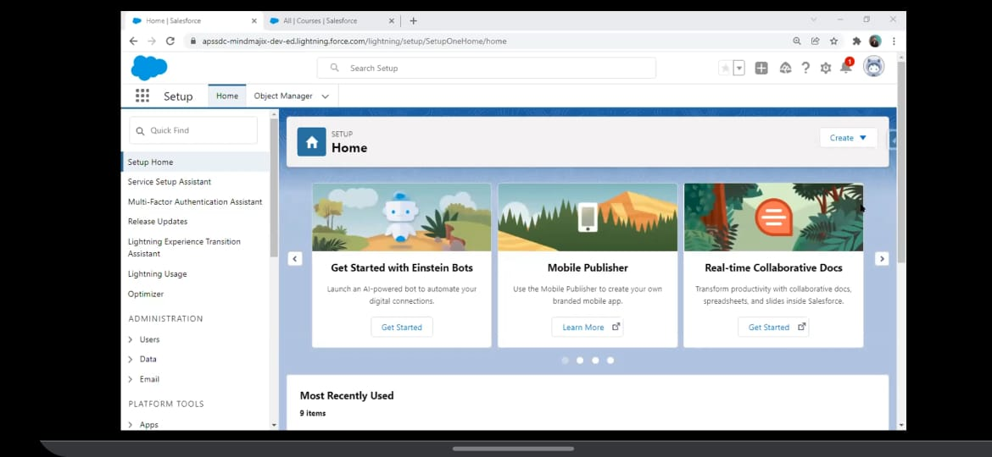

**Topic**: Custom Object Creation

**Milestones/Activities:**

**Topics:**

### **1)** Create The Custom Objects For The Application

**Description:** We have to create a custom object

a)Courses

b)Trainer

c)Student

d)Meeting

e)Batch/Class Scheduling

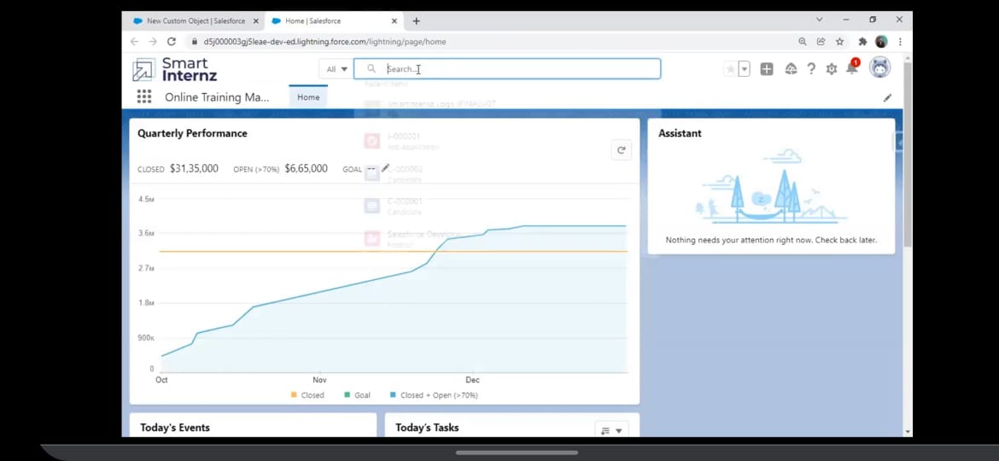

### **2)** Create Custom Fields On Course Object

**Description:** We have to create a custom custom feilds on course object

|  |  |  |
| --- | --- | --- |
| Field Name | DataType | Values |
| Course ID | Auto Number(Change the data type to AutoNumber  While creating course object and changing record  Type to course id) | Format(C-000001)  Starting number=1 |
| Course Name | Text |  |
| Course Duration | Picklist | 1month,2 months,3 months |
| Course Fees | Currency |  |
| Course Description | Text(Long) |  |
| Course Category | Picklist | Data science, cloud computing, AI, ML |
| Course Trainer | Master-Detail(Trainer) |  |

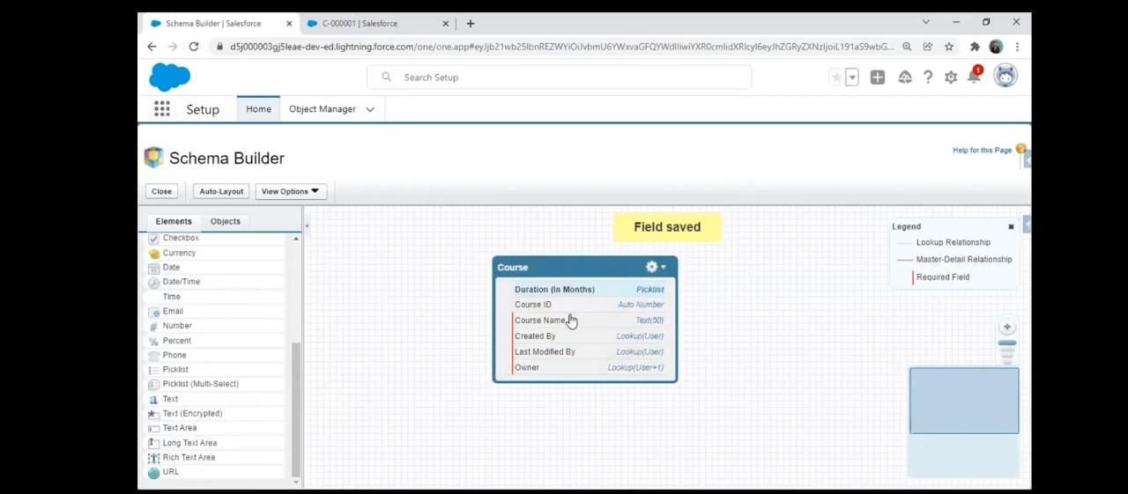**DAY:2**

### **3)** Create Custom Fields On Trainer Object

### **Description:** We have to Create Custom Fields On Trainer Object

|  |  |  |
| --- | --- | --- |
| Field Name | Data Type | Values |
| Trainer ID | Autonumber | Format=T-00001,Starting number=1 |
| Full Name | Text |  |
| Email | Email |  |
| PhoneNumber | Phone |  |
| Whatsapp Number | Phone |  |
| DateofBirth | Date |  |
| Age | Formula | TODAY()-Date_of_Birth__c |
| Experience | Picklist | 1year,2years,3years,……… |
| LinkedIN Profile | URL |  |
| Expertise | Text |  |

### 4)Create Custom Fields On Student Object

**Description:** I have created a custom fields on subject object

|  |  |  |
| --- | --- | --- |
| Field Name | Data Type | Values |
| Student ID | Autonumber | Format=S-00001,Starting Number=1 |
| First Name | Text |  |
| Last Name | Text |  |
| Email | Email |  |
| PhoneNumber | Phone |  |
| Date Of Birth | Date |  |
| Whatsapp Number | Phone |  |
| Enrollment Date | Formula | TODAY() |
| Student Enrollment | Master Detail(Batch) |  |

### 5)Create Custom Fields On Meeting Object

**Description:** I have created an custom fields on meeting object

|  |  |  |
| --- | --- | --- |
| Meeting ID | Autonumber | Format=M-00001, Starting Number=1 |
| Valid From | Date |  |
| Valid To | Date |  |
| Active | Checkbox |  |
| Meeting Link | URL |  |

### 6) Create Custom Fields On Batch Object

**Description:** I have created a custom fields on batch object

|  |  |  |
| --- | --- | --- |
| Field Name | Data Type | Values |
| Batch ID | Auto Number | Format=B-00001  Starting Number=1 |
| Batch Type | Picklist | Weekday, Weekend |
| Start Date | Date |  |
| End Date | Date |  |
| Course ID | Lookup(Course) |  |
| Meeting id | Lookup(Meeting) |  |
| Trainer id | Lookup(Trainer) |  |
| Status | Picklist | Scheduled/Started/Completed |
| Number Of Students Enrolled | Rollup Summary(Count) |  |
| Details | Formula(Text) | Course_ID__r.Course_Name__c & Trainer_ID__r.FullName__c & Meeting_ID__r.Meeting_Link__c |

**DAY: 3**

**Topic:** Create Validation Rules

**Milestones/Activities:**

**Topics:**

### 1)Create Validation Rules On Course Object

**Description:** I have to Create an validation rules on couse object

1.Course Fees Cannot be Negative:

formula enter "Course_Fee__c<0", give error message according to the condition.

2.Course Fees Should Be Less than 3000$:

give your rule a name and in error condition formula enter "Course_Fee__c>=3000",give error message according to the condition.

### 2)Create Validation Rules On Trainer Object

**Description:** I have to Create an validation rules on Trainer Object

1.Full Name, Phone Number, Dateof Birth , Experience fields on the trainer object should not be blank: Search for Trainer Object from the object manager

2. Age Should Not Be Less than 25 years: Enter "age__c<25" in error condition formula

3.Phone Number and Whatsapp Number should accept minimum 10 digits and maximum 15 digits:

### 3)Create Validation Rules On Student Object

**Description:** I have to create an validation rules on Student Object

1. Lastname should not be Blank: enter the following error condition formula "ISBLANK(Field name)"

2. Minimum 16 years of age: student should be minimum 16 years of age, in error condition formula enter "age__c<16"

3.Phone and whatsappNumber should be minimum 10 digits : in error condition formula enter "NOT(REGEX(Fieldname, "[0-9]{10}"))"

### 4)Create Validation Rules On Meeting Object

**Description:** I have to create an validation rule on Meeting Object

1. Valid From should not be less than current date: Click on validation rules from meeting object, give your rule a name and in error condition formula enter "Valid_from__c < TODAY()"

2.ValidTo Cannot be less than Valid from : Click on validation rules from meeting object, give your rule a name and in error condition formula enter "Valid_to__c < Valid_from__c "

3. Minimum 14 days difference should be in between valid from and valid to : Click on validation rules from meeting object, give your rule a name and in error condition formula enter "Valid_to__c - Valid_from__c < 14 "

### DAY:4

### **Topic:**Process Automation

**Milestones/Activities:**

**Topics:**

There are four automation tools in salesforce:

1. Approval Process

2. Process builder

3. Flows

4. Workflows

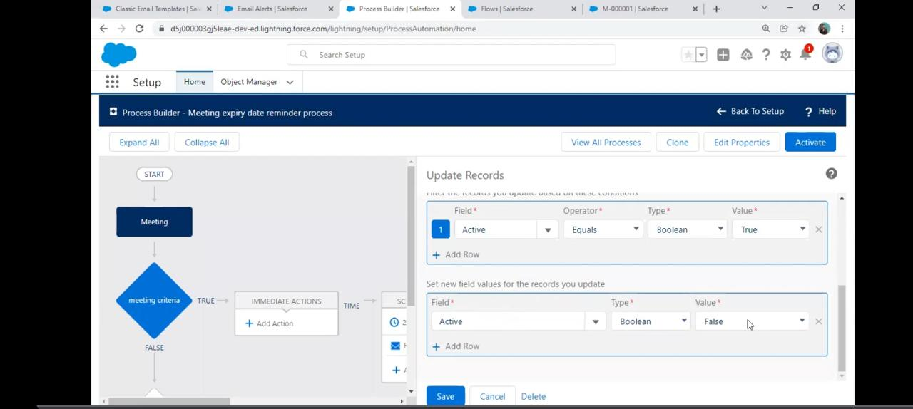

### 1)Creating Work Flow Rules On Meeting Object:

**Description:** I have to creating work flow rules on meeting object

1. create work flow rule 1 day after valid to date the active check box will uncheck

a) from set up search for work flow rules

b) enter rule name , in evaluation criteria select created

c) in formula section " TODAY()- VALID_TO__C= 1"

d) from work flow action select field update.

e) give a name for your work flow action

2.create work flow rule 1 day before valid to date

a) from set up search for work flow rules

b) enter rule name , in evaluation criteria select created

c) in formula section " VALID_TO__C - TODAY () = 1"

d) from work flow action select email alert.

e) enter all mandatory details , select an email template

### 2) Create Work Flow Rules On Class/Batch Object:

**Description:** I have to create an work floe rules on class/batch object

1.create work flow rule 2 days before valid to date send a reminder email

a) from set up search for work flow rules

b) enter rule name

c) in formula section " VALID_TO__C - TODAY () = 2"

d) from work flow action select email alert.

e) enter all mandatory details , select an email template

**DAY:5**

### Topic:Creating Custom Pages Using Visualforce

**Milestones/Activities:**

**Topics:**

### 1)Creating New Course Using Custom Controller:

**Description:** I had created an new course using custom controller

<apex:page lightningStylesheets="true" controller="course">  
 <apex:form >  
 <apex:sectionHeader title="New Course"/>  
 <apex:pageMessages ></apex:pageMessages>  
 <apex:pageBlock >  
 <apex:pageBlockSection >  
 <apex:inputfield value="{!cr.Course_Name__c}"/>  
 <apex:inputfield value="{!cr.Course_Category__c}"/>  
 <apex:inputfield value="{!cr.Course_Fee__c}"/>  
 <apex:inputfield value="{!cr.Duration_In_Months__c}"/>  
 <apex:inputfield value="{!cr.Course_Description__c}"/>  
 </apex:pageBlockSection>  
 <center><apex:commandButton value="Save" action="{!save}"/></center>  
 </apex:pageBlock>  
 </apex:form>  
</apex:page>

public with sharing class course   
{  
public Course__c cr{get;set;}  
public course()  
{  
cr=new Course__c();  
}  
  
public void save() {  
if(cr.Course_Fee__c <0 || cr.Course_Fee__c>3000 )  
 {  
 ApexPages.addmessage(new ApexPages.message(ApexPages.severity.Error, 'Course Fee Should be less Than 3000 and Cannot Be Negative'));  
 }  
 else{  
insert cr;  
 ApexPages.addmessage(new ApexPages.message(ApexPages.severity.Confirm, 'Record Inserted Successsfully'));  
 cr=new Course__c();  
 }  
   
 }  
}

**DAY:6**

### 2)Create New Trainer Using Custom Controller:

**Description:** I have to create new trainer using custom controller

**Trainer visualforce code:**

<apex:page lightningStylesheets="true" controller="trainer">  
 <apex:form >  
 <apex:sectionHeader title="New Trainer"/>  
 <apex:pageMessages ></apex:pageMessages>  
 <apex:pageBlock >  
 <apex:pageBlockSection >  
 <apex:inputfield value="{!tr.Full_Name__c}" required="true"/>  
   
 <apex:inputfield value="{!tr.Phone_Number__c}" required="true"/>  
 <apex:inputfield value="{!tr.WhatsApp_Number__c}"/>  
 <apex:inputfield value="{!tr.Date_Of_Birth__c}" required="true"/>  
 <apex:inputfield value="{!tr.Experience__c}" required="true"/>  
   
 <apex:inputfield value="{!tr.Expertise__c}"/>  
   
</apex:pageBlockSection>  
 <center><apex:commandButton value="Save" action="{!save}"/></center>  
 </apex:pageBlock>  
 </apex:form>  
</apex:page>

**Trainer Apex code:**

public with sharing class trainer {  
public Trainer__c tr{get; set;}  
public trainer()  
{  
tr=new Trainer__c();  
}

public void save()  
{  
 insert tr;  
 ApexPages.addmessage(new ApexPages.message(ApexPages.severity.Confirm, 'Record Inserted Successsfully'));  
 tr=new Trainer__c();  
   
}  
}

**DAY:7**

### 3)Create New Student Using Standard Controller

**Description:** I have to created an new steudent using standard controller

|  |  |
| --- | --- |
| |  | | --- | | <apex:page lightningStylesheets="true" standardController="Student__c">  <apex:form >  <apex:sectionHeader title="New Student"/>  <apex:pageBlock >  <apex:pageBlockSection >  <apex:inputField value="{!Student__c.First_Name__c}"/>  <apex:inputField value="{!Student__c.Last_Name__c}" required="true"/>  <apex:inputField value="{!Student__c.Email_ID__c}"/>  <apex:inputField value="{!Student__c.Phone_Number__c}"/>  <apex:inputField value="{!Student__c.Date_Of_Birth__c}"/>  <apex:inputField value="{!Student__c.WhatsApp_Number__c}"/>  </apex:pageBlockSection>  <center><apex:commandButton value="Save" action="{!save}"/></center>  </apex:pageBlock>  </apex:form> </apex:page> | |

**DAY: 8**

### 4)Create New Meeting Using Standard Controller

Meeting visualforce code:

<apex:page lightningStylesheets="true" standardController="Meeting__c">

<apex:form >

<apex:sectionHeader title="New Meeting"/>

<apex:PageBlock >

<apex:PageBlockSection >

<apex:inputField value="{!Meeting__c.Valid_From__c}"/>

<apex:inputField value="{!Meeting__c.Valid_To__c}"/>

<apex:inputField value="{!Meeting__c.Meeting_Link__c}"/>

<apex:inputField value="{!Meeting__c.Active__c}"/>

</apex:PageBlockSection>

<center><apex:commandButton value="Save" action="{!save}"/></center>

</apex:PageBlock>

</apex:form>

</apex:page>

**DAY:9**

### Topic:Create New Batch Using Standard Controller

**Milestones/Activities:**

**Topics:**

**Batch visualforce code:**

<apex:page lightningStylesheets="true" standardController="Batch__c">

<apex:form >

<apex:sectionHeader title="New Batch"/>

<apex:pageBlock >

<apex:pageBlockSection >

<apex:inputField value="{!Batch__c.Batch_Type__c}"/>

<apex:inputField value="{!Batch__c.Start_Date__c}"/>

<apex:inputField value="{!Batch__c.End_Date__c}"/>

<apex:inputField value="{!Batch__c.Course_ID__c}"/>

<apex:inputField value="{!Batch__c.Meeting_ID__c}"/>

<apex:inputField value="{!Batch__c.Trainer_ID__c}"/>

<apex:inputField value="{!Batch__c.Status__c}"/>

</apex:pageBlockSection>

<center><apex:commandButton value="Save" action="{!save}"/></center>

</apex:pageBlock>

</apex:form>

</apex:page>

**DAY:10**

### Topic:Triggers

**Milestones/Activities:**

**Topics:**

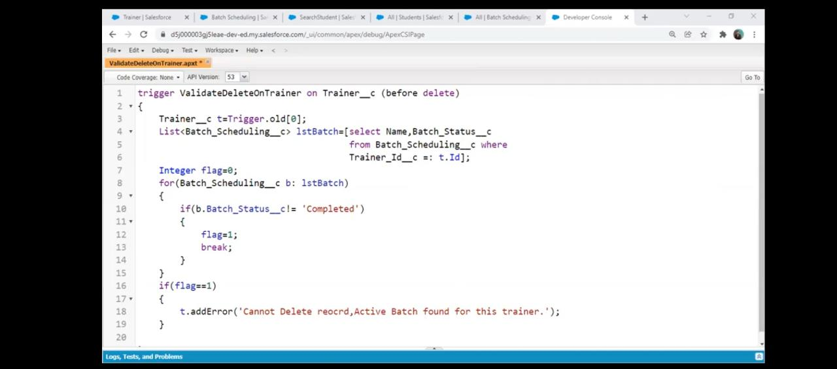

### 1)Trigger On Trainer Object:

**Description:** create an trigger on trigger object

trigger age on Trainer__c (before insert,before update)

{

for(Trainer__c tr :trigger.new)

{

date dob = tr.Date_of_Birth__c;

Integer age = Integer.valueOf(dob.daysBetween(Date.Today()))/365;

if(age<25){

tr.Date_of_Birth__c.adderror('Age should be more than 25');

}

}

}

**DAY:11**

### 2)Trigger On Student Object:

**Description:** create an trigger on student object

trigger ageCheck on Student__c (before insert)

{

for(Student__c std :trigger.new)

{

date dob = std.Date_of_Birth__c;

Integer age = Integer.valueOf(dob.daysBetween(Date.Today()))/365;

if(age<25){

std.Date_of_Birth__c.adderror('Age should be more than 16');

}

}

}

**DAY:12**

### 3)Trigger On Meeting Object:

**Description:** Create an trigger on meeting object

trigger Datecheck on Meeting__c (before insert)

{

for(Meeting__c mt :trigger.new)

{

if(mt.Valid_From__c<Date.today() )

{

mt.Valid_From__c.adderror('Valid From Date Should Be Greater Than Today');

}

if(mt.Valid_To__c < mt.Valid_From__c)

{

mt.Valid_To__c.adderror('Valid To Date shouldbe greater than valid from date');

}

Integer noOfDays = (mt.Valid_From__c). daysBetween(mt.Valid_To__c);

if(noOfDays < 14)

{

mt.Valid_From__c.adderror('Minimum 14 days difference should be present between one meeting');

}

}

}